* It is used to sharing functionality.
* Hoc Accept component and enhance and return components.
* Used to share common functionality without having return same code multiple times

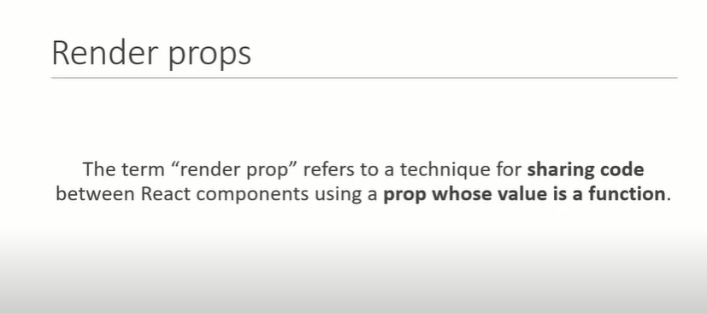

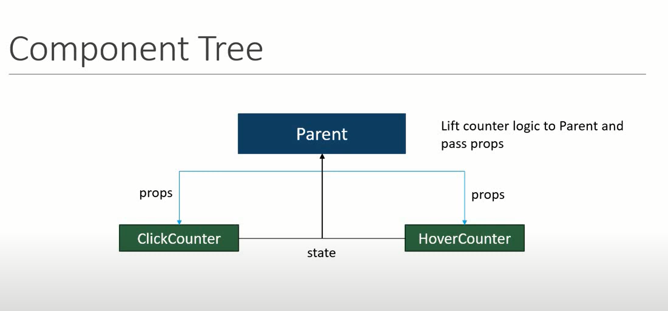

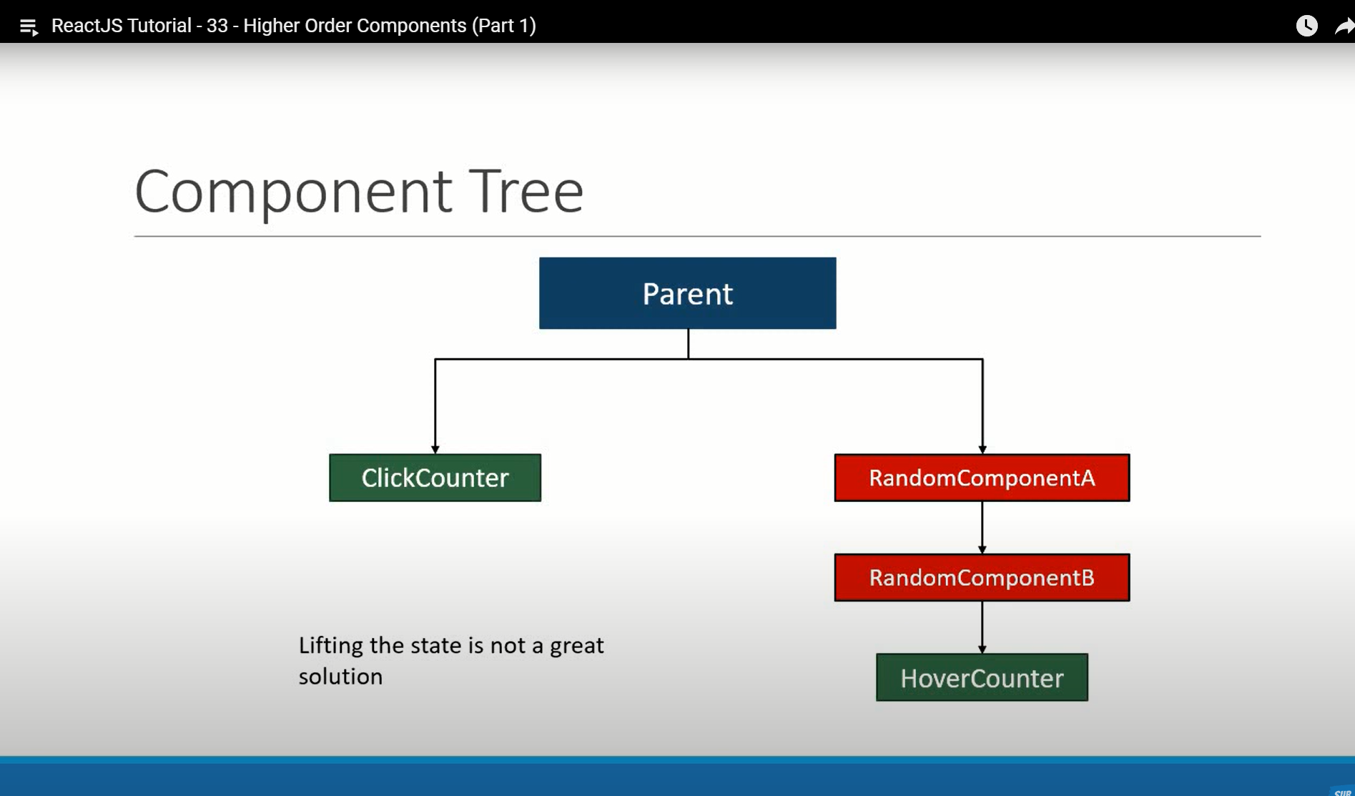

Example :

I have to component counting click and hover click :

First Component

import React, { Component } from 'react'

 class ClickCounter extends Component {

    constructor(props) {

      super(props)

      this.state = {

         count:0

      }

    }

    incrementCount=()=>{

        this.setState(prevState=>{

            return { count : prevState.count +1}

        })

    }

  render() {

    const { count } = this.state

    return <button onClick={this.incrementCount}>click {count} times</button>

  }

}

export default ClickCounter

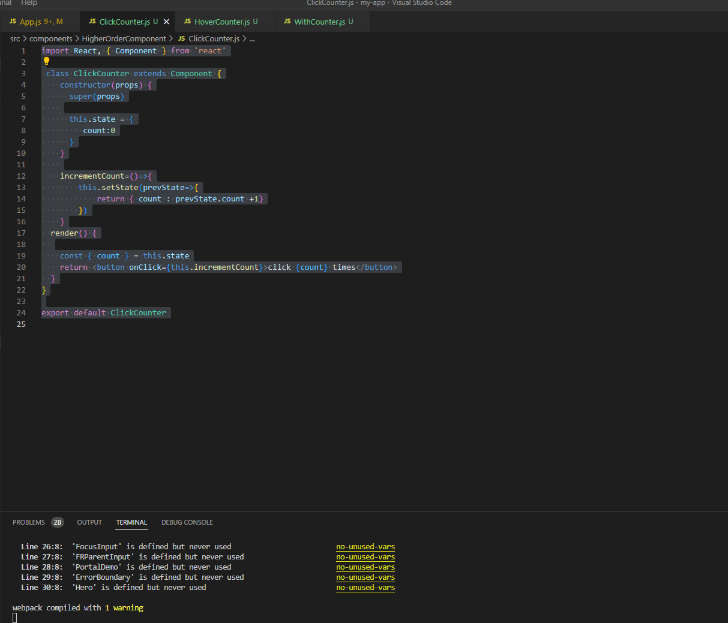

Second component For Hover counting :

import React, { Component } from 'react'

export class HoverCounter extends Component {

  constructor(props) {

    super(props)

    this.state = {

       count:0

    }

  }

  incrementCount=()=>{

      this.setState(prevState=>{

          return { count : prevState.count +1}

      })

    }

  render() {

    const { count } = this.state

    return <label onMouseOver={this.incrementCount}>Hovered {count} times</label>

  }

}

export default HoverCounter

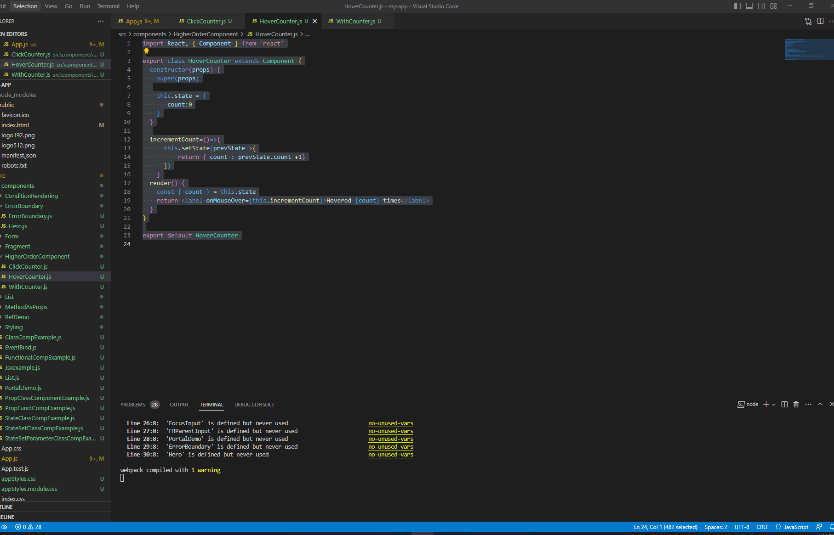

We are using same code for Counting in both the component



Now We are going to do common code now in picture Hoc :

In App.js we are calling both component :

<ClickCounter></ClickCounter>

<HoverCounter></HoverCounter>

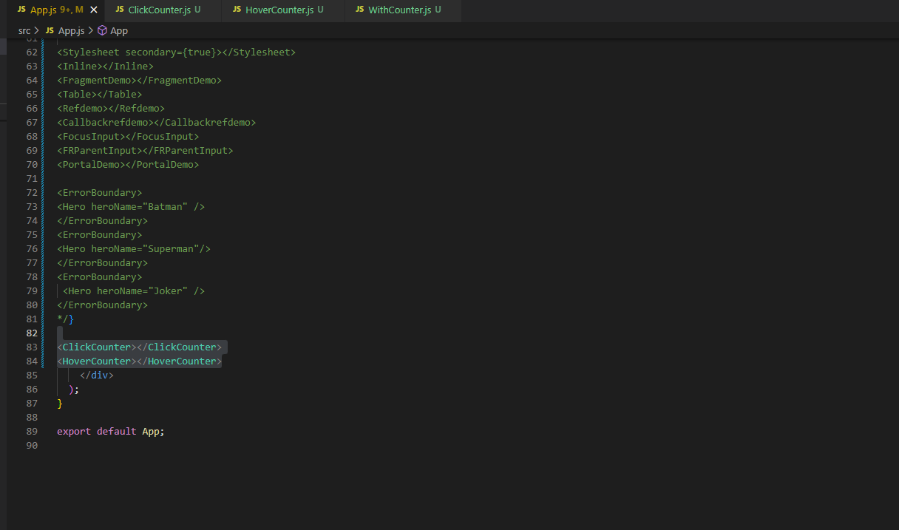

Now Create one new component for common code and returning orginal component :

import React from "react";

const UpdatedComponent=(OriginalComponent) => {

    class NewComponent extends React.Component{

        render(){

            return <OriginalComponent/>

        }

    }

    return NewComponent

}

export default UpdatedComponent

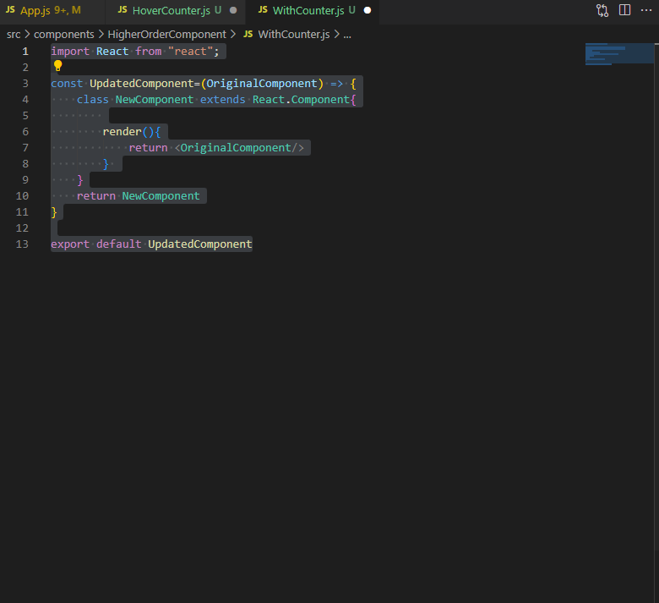

Now We are going to shift Common code to Both component => ClickCounter.js and HoverCounter.js

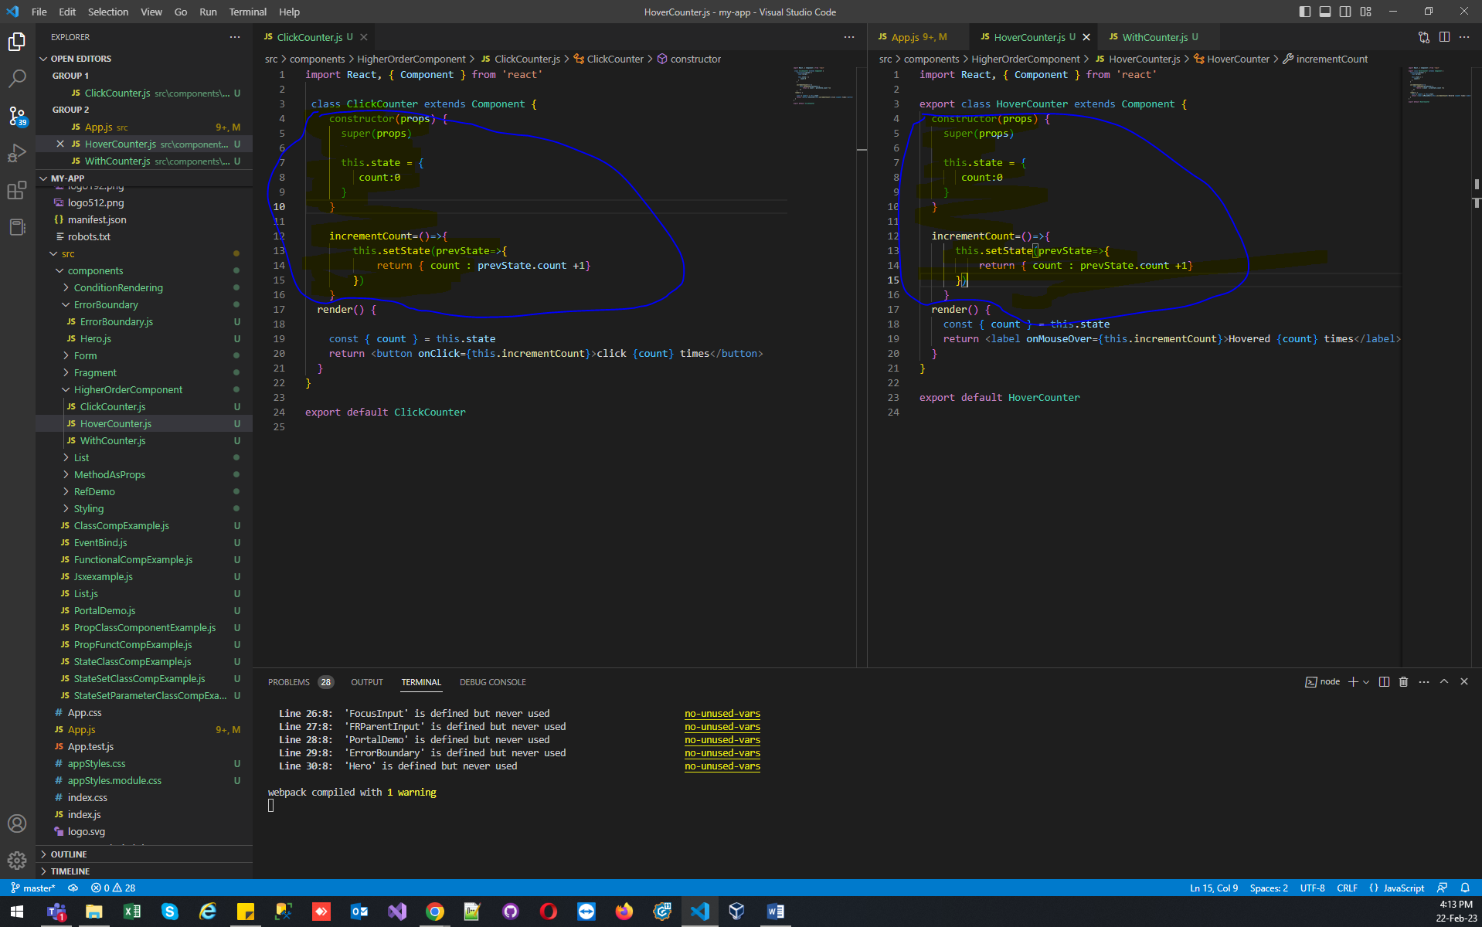

Now Shifted In New Component :

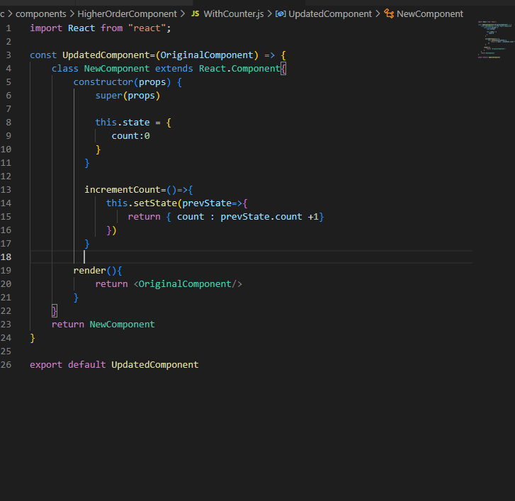

import React from "react";

const UpdatedComponent=(OriginalComponent) => {

    class NewComponent extends React.Component{

        constructor(props) {

            super(props)

            this.state = {

               count:0

            }

          }

          incrementCount=()=>{

              this.setState(prevState=>{

                  return { count : prevState.count +1}

              })

          }

        render(){

            return <OriginalComponent/>

        }

    }

    return NewComponent

}

export default UpdatedComponent

And Deleted From both the component

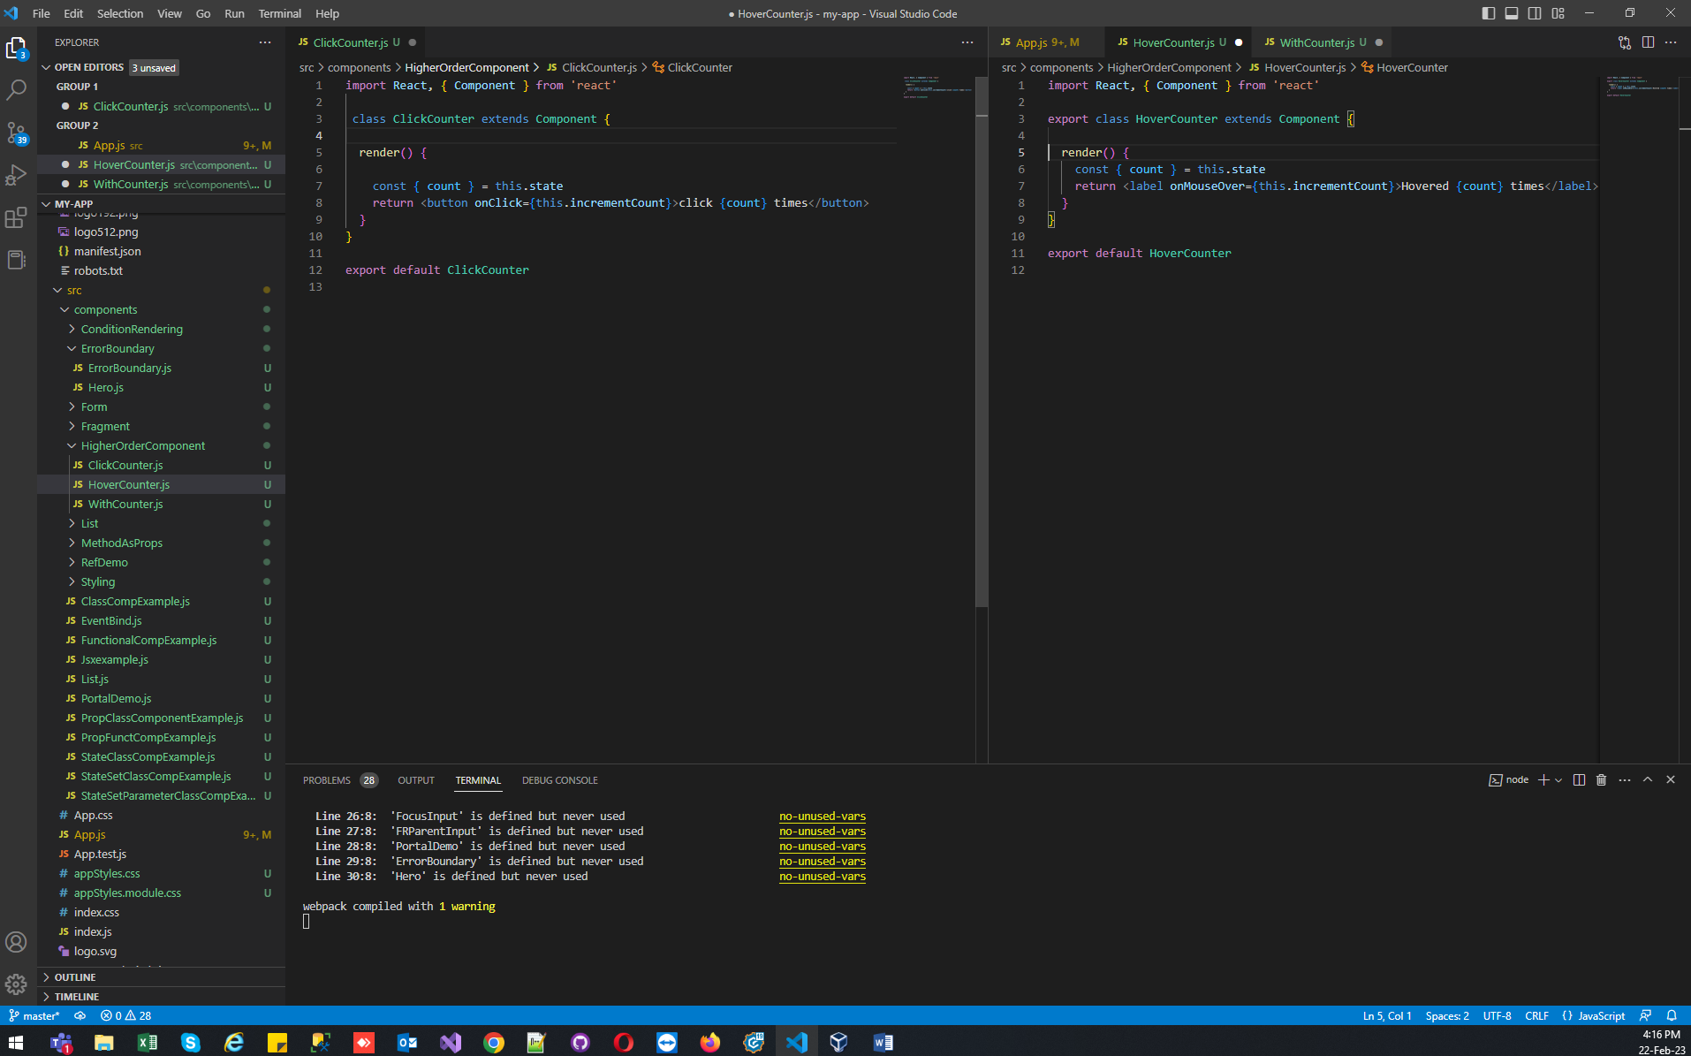

Now add Props In Common Component (WithCounter.js):

import React from "react";

const UpdatedComponent=(OriginalComponent) => {

    class NewComponent extends React.Component{

        constructor(props) {

            super(props)

            this.state = {

               count:0

            }

          }

          incrementCount=()=>{

              this.setState(prevState=>{

                  return { count : prevState.count +1}

              })

          }

        render(){

            return <OriginalComponent count={this.state.count}

            incrementCount={this.incrementCount}/>

        }

    }

    return NewComponent

}

export default UpdatedComponent

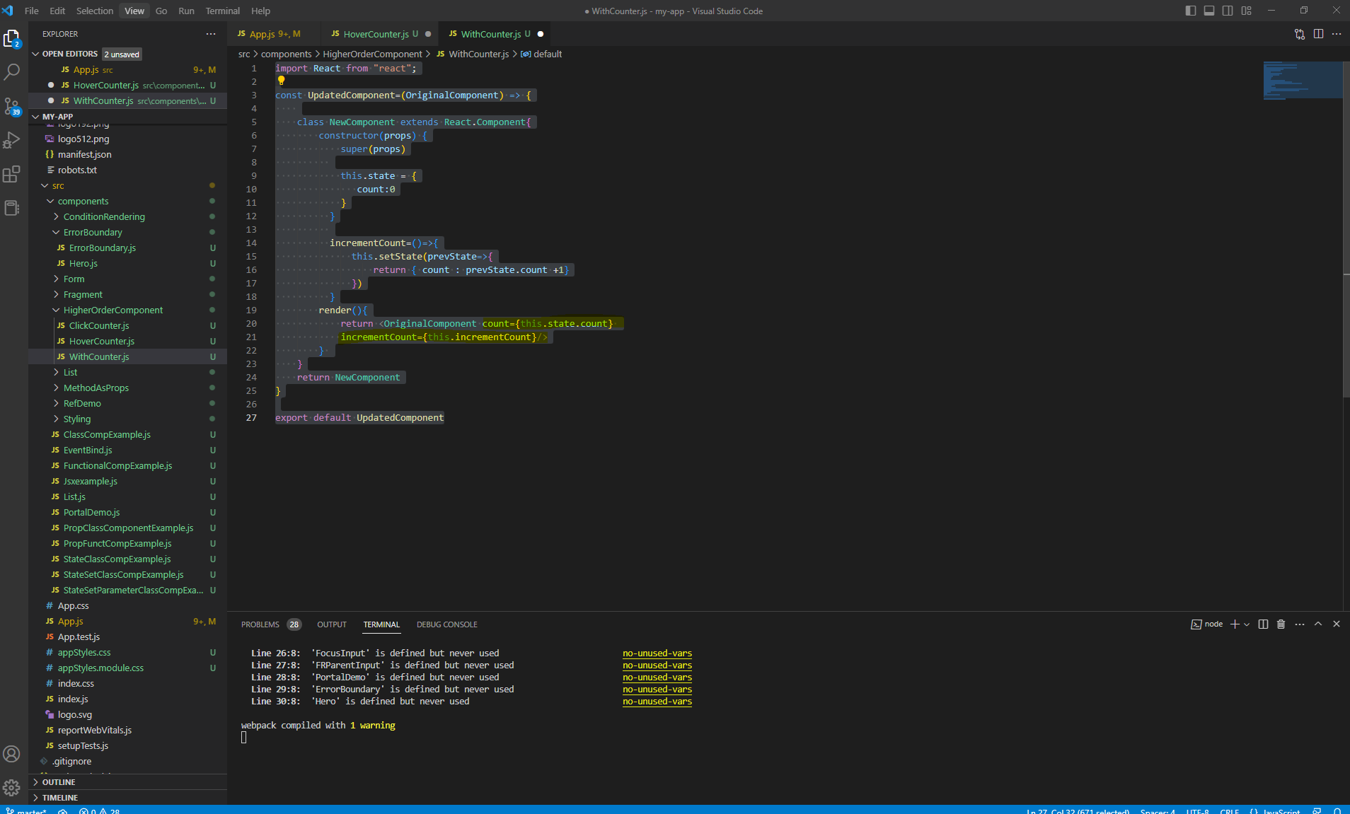

Now added prop use in other component like ClickCounter.js and HoverCounter.js

Remember We have to export our common component from both the component and use the property of passed from common component(Clickcounter.js)

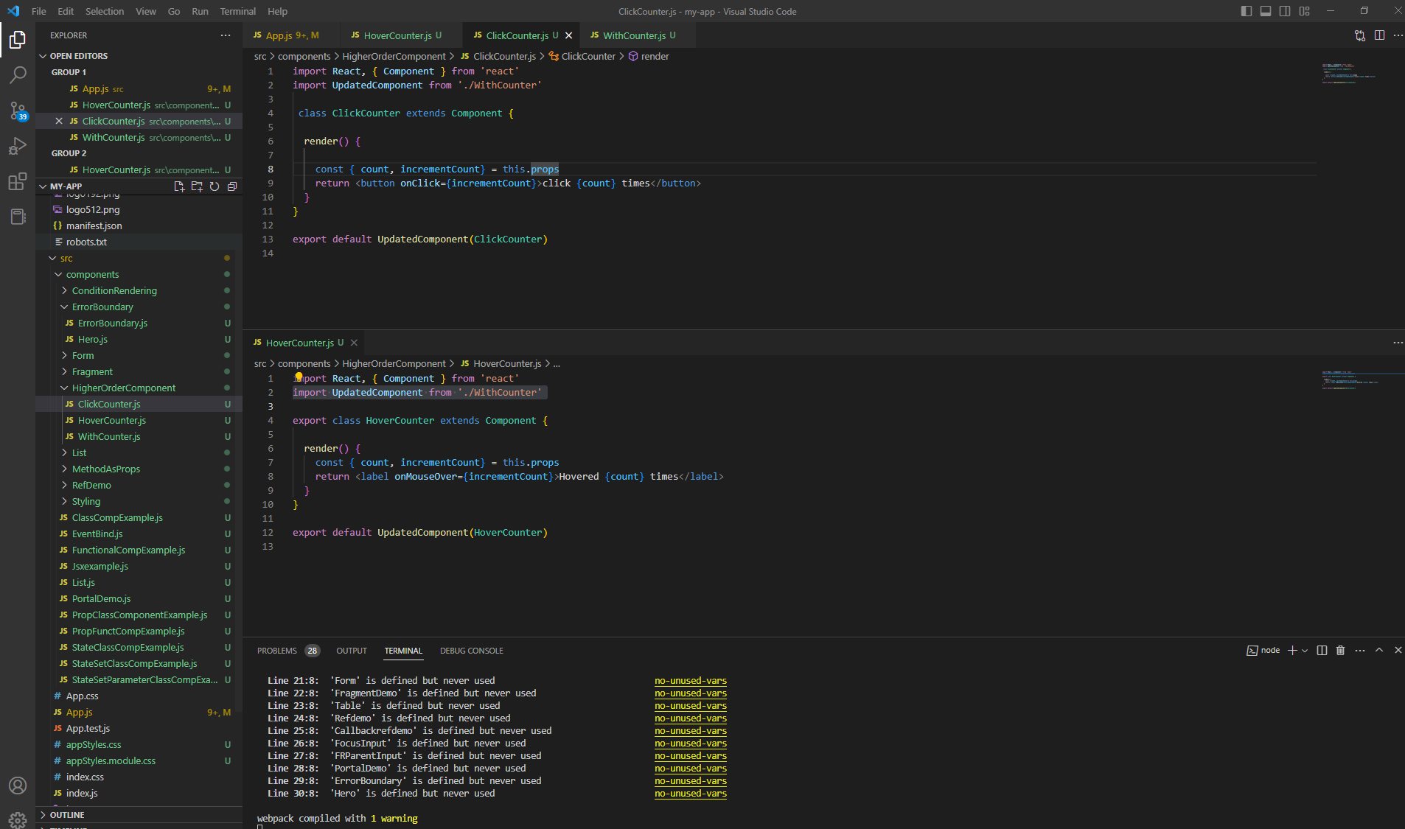

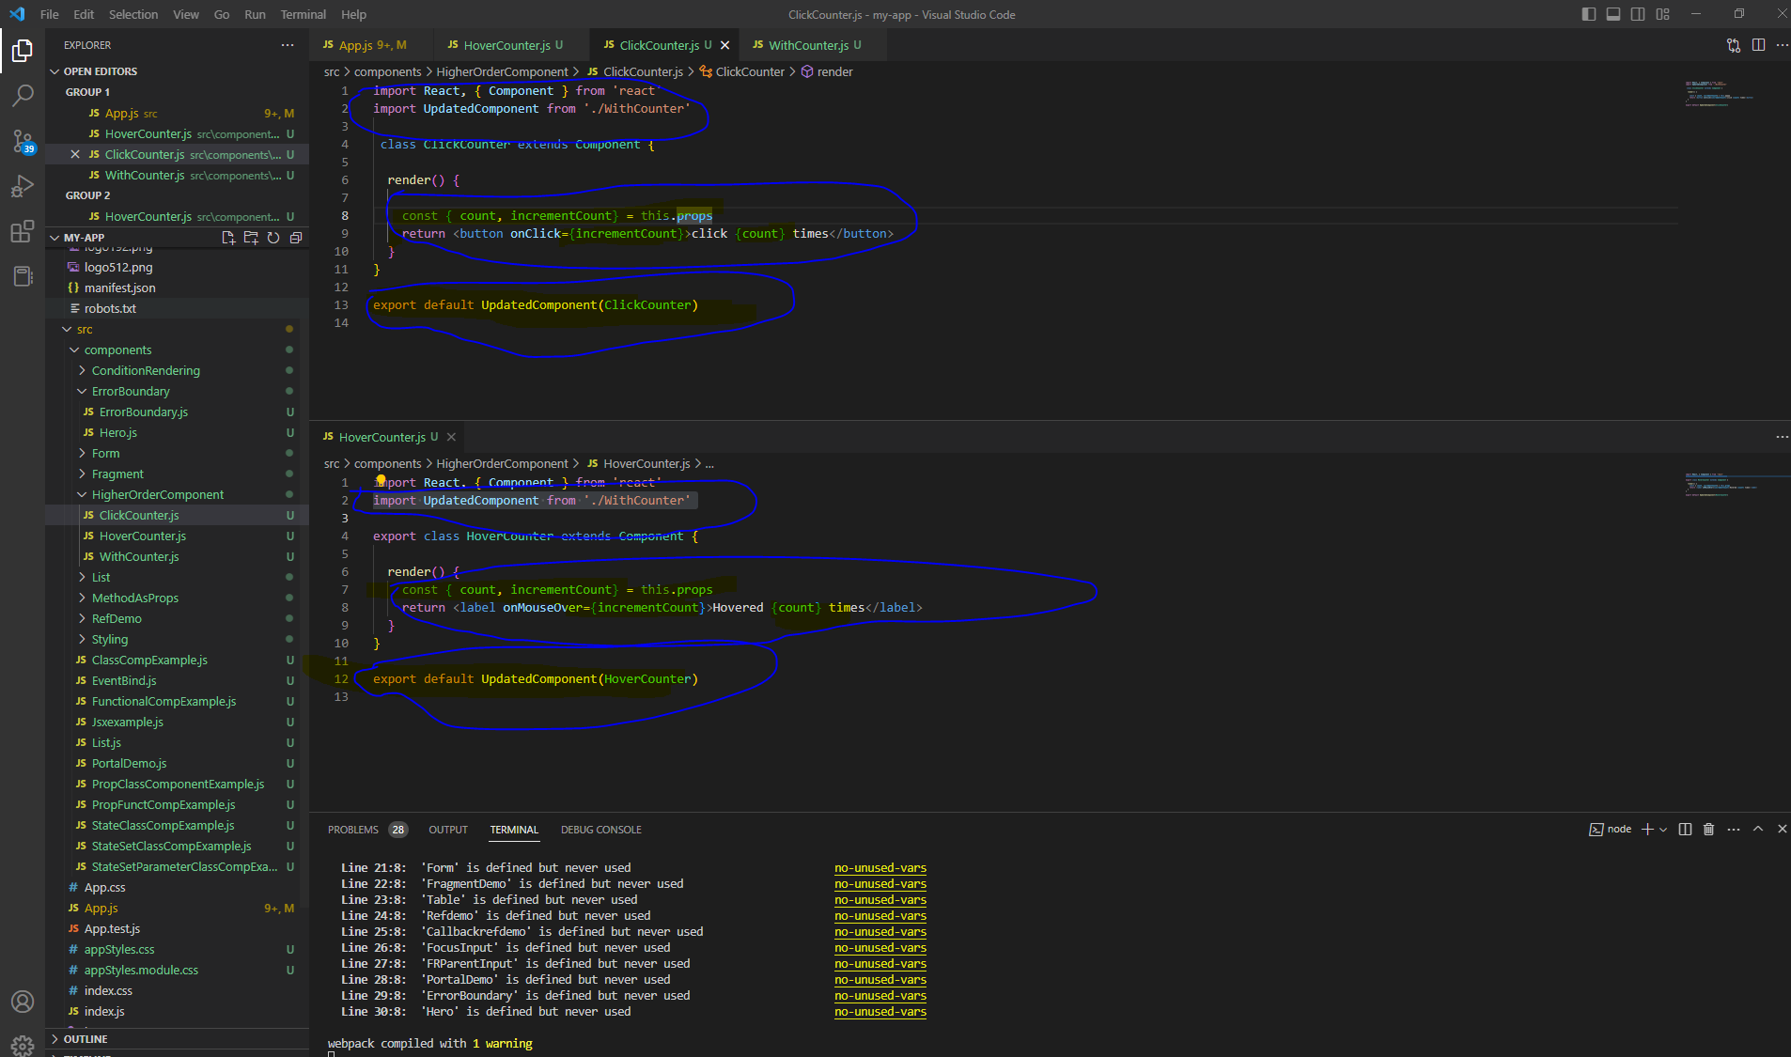

Output :

